Thank you to our SponsoR

  - Servicing Southern California
Roofing  - Maintenance of any roof system  - Repairs of all types  - Replacement roofs:  - Shingle and tile  - Hot asphalt and cold process  - TPO, PVC and KEE  - Cool roof coatings | Decking  - Maintenance coating  - Repairs of many systems  - Full replacements  - Decorative textures
Gutters  - Cleaning and maintenance  - Repairs  - New seamless aluminum gutters  - New custom steel and copper gutters. | Emergencies  - 24/7 Live response  - Crews on call 365 days a year  - Plastic tarping  - Temporary fixes  - Emergency water pumping
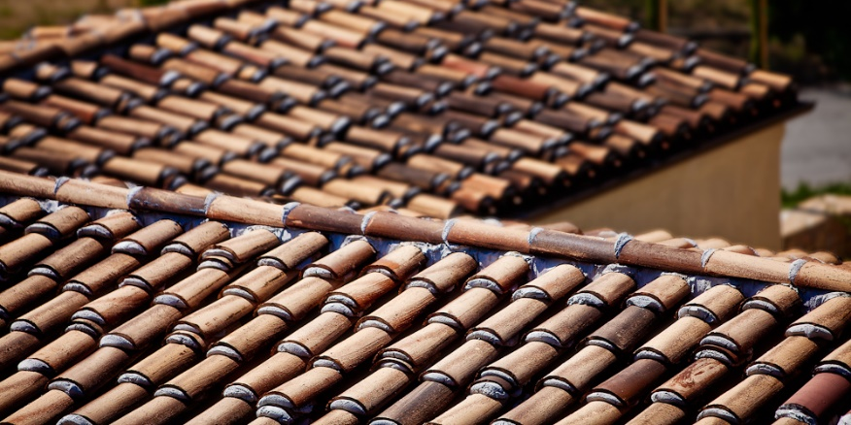 | 