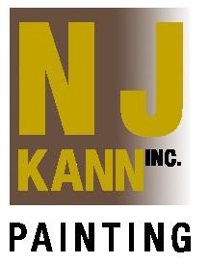

**OUR MISSION**

**The sole mission of our company is to provide unparalleled customer service in every part of the project. N.J. Kann Painting Inc. utilizes the latest techniques in all areas of their performance. We employ only top notch seasoned professionals, who are fully versed in the difficulties in completing a successful HOA project. Our teams are fully trained in all aspects of safety and client services.**

**SERVICES**

* **Exterior Painting**
* **Interior Painting**
* **Budget Planning**
* **Expert Color Consultations**
* **Multi-Color Schemes**
* **Warranty Programs**
* **Maintenance Programs**
* **Complete Surface Preparation**
* **Color Change & Building Plotting**
* Deck & Floor Coatings