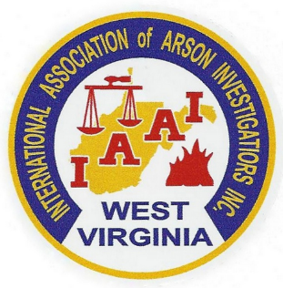

The West Virginia Chapter
of the
International Association of Arson Investigators
Presents
2019 Fire Investigation Conference

Monday and Tuesday, October 7th and 8th 2019
Morgantown, West Virginia

Topics include:
Scientific Method (2 hours) and Fire Dynamics/Appliance Failures (6 hours)
Jason Karasinski (Fire Research and Technology, LLC)
This course will assist investigators in how to apply the Scientific Method to fire investigation. Understanding how fires start, spread, and develop is an essential part of any fire investigation. The basics of appliance failures will also be covered.

Fire Death Investigation (4 hours)
Jeffrey Springer, MD (Medical Examiner, Commonwealth of Kentucky)
Lt. Henry Ott (Louisville Police Department)
This course will discuss what data should be collected by the fire investigator at a fatal fire and how the autopsy can assist in the investigation. There will be discussion of degrees of thermal injury, the pathophysiology of smoke inhalation, postmortem thermal artifacts, and how to determine if someone died before the fire began. There will also be a short discussion of the injuries produced by explosions.

ATF-Financial Investigative Services Division: Only a Phone Call Away (4 hours)
Jonathan Esworthy (ATF)
Charles Strange (ATF)
Learn how to request the assistance and the benefits of using an ATF Forensic Auditor. Also, learn how an ATF auditor conducts financial investigations. Adjudicated case studies will be discussed including those in West Virginia as well as those involving homicides.

Host Hotel and Conference Center

1188 Pineview Drive
Morgantown, WV 26505
304-241-6649
www.holidayinn.com/morgantownunv

ROOM AVAILABILITY

A block of rooms is reserved for arrival on
Sunday, October 6th with check out on Tuesday, October 8th .
The cost per room is $97.00.

The Group Name is
Fire Investigators Conference IAAI 2019

September 20th, 2019 is the last day to book at this rate. The room block is limited and you are encouraged to make your room reservation immediately.

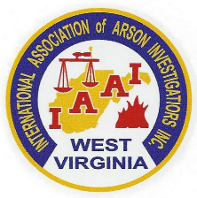
SEMINAR REGISTRATION

IAAI Members $175.00
Non-Members $200.00
Students* $100.00
*Student rate applies to those currently enrolled in a Fire Science, Forensics or Criminal Justice program. Registration scholarships are available for a limited number of students. Contact George Harms for more information

Registrations received after the class size limit is reached will be returned.

PLEASE REGISTER EARLY

This is a tested course for points toward IAAI-CFI Continuing Education and Law Enforcement in-service training credit. Training Certificates are issued by the West Virginia Chapter of the IAAI.
The WVIAAI reserves the right to refuse admission to any party.

Name: _______________________________________________________

Organization: _______________________________________________________

Address: _______________________________________________________

_______________________________________________________

Telephone: _______________________________________________________

E-mail: _______________________________________________________

T-shirt Size ___________ * for those pre-registered only

Seminar Schedule: Seminar Contacts:

Classes: 8:00 am – 5:00 pm both days George Harms 304-279-3344
Lunch on your own from 12:00 am – 1:00 pm Korri Powers 304-542-6126

Return registration form with payment to:
West Virginia Chapter IAAI
P. O. Box 1218
Scott Depot, WV 25560

You may email registrations to korrih@yahoo.com or george.a.harms@wv.gov

