
November 3rd -5th 2026 IAAI Annual Conference Post Falls, Idaho

IAAI Idaho Chapter 56 Annual Conference – 24 Hours CE / POST Training (Nov 4–6, 2025, 8:00 AM – 5:00 PM) This track is designed for experienced investigators and provides 24 hours of tested Continuing Education and POST (pending ap-proval)- training, taught by nationally recognized instructors in advanced topics:ber

IAAI Idaho Chapter 56 Annual Conference – 24 Hours CE / POST Training (Nov 3–5, 2026, 8:00 AM – 5:00 PM) This track is designed for experienced investigators and provides 24 hours of tested Continuing Education and POST (pending approval)- training, taught by nationally recognized instructors in advanced topics:

Tommy Sipsy, D.F.Sc., M.F.Sc. Rick Jones
- Fire Dynamics &Validating the tools of Fire Investigations
Dr. Kyle Bradshaw
- SciBit Scientific Behavioral Interview Techniques

Chaplin Christa Trinchera
Contaminated Twice: Toxic Exposure, Trauma Recovery, and the Resilience Room™ Model for Arson Investigation Teams

Conference Fees: For the advanced tract Lunches Provided
- Members: $325
- Non-Members: $375

Fundamentals of Fire Investigation – 40 Hour Course (Nov 2–6, 2026) “Class may be canceled if class minimum is not met”. This tested 40-hour course provides the scientific foundation to accurately determine fire origin and cause. It is the base class for earning the IAAI Fire Investigation Technician (FIT) designation and a steppingstone toward Certified Fire Investigator (IAAI-CFI). (lunch is provided M-TH)

IAAI Member cost $750.00 Lunches Provided
Non - Member cost $925

IAAI Idaho Chapter 56 Annual Conference 2026
Post Falls, Idaho · November 2–6, 2026
Kootenai County Fire & Rescue - Training & Maintenance Campus
5271 E Seltice Way
Post Falls Idaho 83854
Tuesday, November 3, 2026
- Fire Dynamics & Validating the tools of Fire Investigations

Tommy Sipsy, D.F.Sc., M.F.Sc. Chief Fire & Explosion Investigator, Southern Company Gas & Richard
Jones, IAAI-CFI(V), IAAI-ECT, IAAI-CI
Tommy Sipsy serves as the Chief Fire & Explosion Investigator for Southern
Company Gas, where he has dedicated over 40 years of service. With a distinguished
career rooted in fire science and forensic investigation, Mr. Sipsy is
widely respected for his technical expertise and leadership in fire and explosion
analysis.
Mr. Sipsy holds a doctorate and master’s degree in forensic science from Oklahoma
State University, as well as a bachelor’s degree in fire science—
concentrating in fire, arson, and explosion—from Eastern Kentucky University.
In his current role, he works closely with both public and private sector investigators, conducting detailed
investigations of fire and explosion incidents and assisting with the assessment and testing of natural
gas systems on and around affected premises.
With more than 40 years of experience working with NFPA 54 and CFR 49.192 fuel gas codes and regulations,
Mr. Sipsy has developed deep subject matter expertise in regulatory compliance and forensic fire
analysis. He is a Certified Fire and Explosion Investigator (CFEI) through the National Association of Fire Investigators
and holds additional certifications from the International Association of Arson Investigators
(IAAI), including Certified Fire Investigator (CFI) and Certified Instructor (CI).
In addition to his professional role, Mr. Sipsy remains active in the fire service community as a reserve volunteer
firefighter with Fannin County. He currently serves as president of the IAAI Foundation, immediate
past president, and T&E chairman of the Georgia Fire Investigators Association (GFIA). He is a dedicated
member of several professional organizations, including:
• International Association of Arson Investigators (Georgia, Tennessee, and Louisiana Chapters)
• Metro Fire Investigators Association
• National Association of Fire Investigators
• Northwest Georgia Fire Investigators Association
• The National Collegiate Honors Society

Richard Jones, IAAI-CFI(V), IAAI-ECT, IAAI-CI
Mr. Jones has over 28 years of experience in the field of investigations for both the public and the private sectors. He also has prior service and training with local fire districts and the Louisiana Office of State Fire Marshal, specializing in the field of fire and explosion investigations. Mr. Jones has completed numerous courses related to fire and explosion investigations sponsored by the National Fire Academy, Maine State Police, the International Association of Arson Investigators, and other federal, state, and local organizations. He earned degrees in Fire Science, Fire Administration, and Fire Investigation from Columbia Southern University and is an experienced lecturer on fire and ex-plosion investigations. Mr. Jones has been recognized as an expert witness and has provided testimony on state, federal, and international levels. He has been actively involved in the International Association of Arson Investigators (IAAI), serving on the Board of Directors for six years and advancing through the executive positions to President for the 2020-2021 term. He also serves as committee co-chair for the IAAI Certifications Committee; on the FISC committee; ITC Training Committee; Editorial Review Committee for the Fire and Arson Investigator Journal; and on the Appellate Review Committee. Additionally, Mr. Jones has been an active member of the Louisiana Chapter of IAAI, previously serving on the Board of Directors and advancing to the position of Chapter President on two occasions. He is a facilitator for the IAAI Evidence Collection Technician (ECT) and Expert Witness/Courtroom Testimony (EWCT) programs and served as committee chair for the IAAI publication Fire Investigator Principles and Practice to NFPA 921 and 1033, for both the 2014 edition and the 2017 edition of the publication. Additionally, he serves as a principal NFPA committee member for NFPA 921 Fire Investigations, a principal for NFPA 302 Motor Craft, an alternate for NFPA 1321 Fire Investigation Units (FIU), NFPA 1300 Standard on Community Risk Assessment and Community Risk Reduction Plan Development, NFPA 1452 Guide for Training Fire Service Personnel to Conduct Community Risk Reduction, NFPA 1730 Standard on Organization and Deployment of Fire Prevention Inspection and Code Enforcement, Plan Review, Investigation, and Public Education Operations, and NFPA 302 Motor Craft.

Wednesday, November 4, 2026
Scientific Behavioral Interview Techniques

Kyle Bradshaw
PhD, CFO, CFI-I, CDM, CFEI

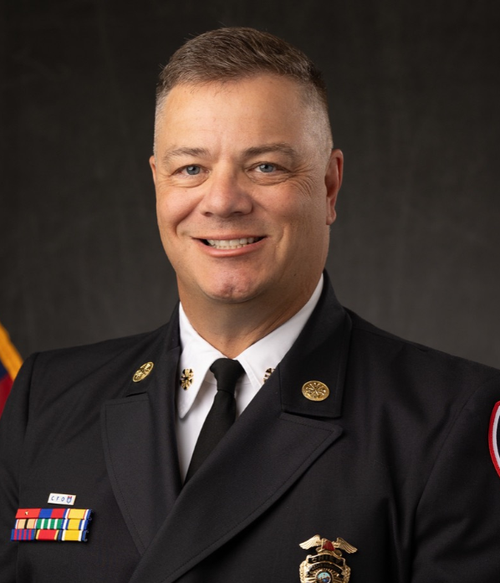
Dr. Bradshaw is an expert in behavioral science, with a deep focus on investigative
methodology grounded in academic qualitative research. As an Arson Investigations Commander and Internal Affairs Commander, he has led extensive investigative operations, overseeing more than 1,700 fire investigations and over 150 internal administrative investigations.
His investigative credentials include certifications as an advanced truth verification analyst using Computer Voice Stress Analysis (CVSA) and advanced Interview and Interrogation Techniques from the Reid Institute. Dr. Bradshaw has contributed to the field by publishing multiple articles on truth verification and the critical nature of administrative investigations.
His career also includes senior executive experience as a Fire Chief and a strong
academic background, with a Bachelor of Science in Homeland Security and Public
Safety, a Master of Science in Executive Fire Service Leadership, and a Ph.D. in Public Policy and Administration: Criminal Justice. He serves as a professor for Columbia Southern University and instructor and is a charter member of the International Academy of Fire & Emergency Services Scholars.

Evening Event: IAAI Idaho Chapter Awards Banquet & Business Meeting – 6:30 PM
Cost for Dinner is an additional $ 30
Kootenai County Fire & Rescue - Training & Maintenance Campus
5271 E Seltice Way
Post Falls Idaho 83854
25 Additional Tickets Available onsite for $30 each
RSVP : Brian Owens brian.owens@doi.idaho.gov. (208)-705-5621
Thursday November 5th
Chaplin Christa Trinchera

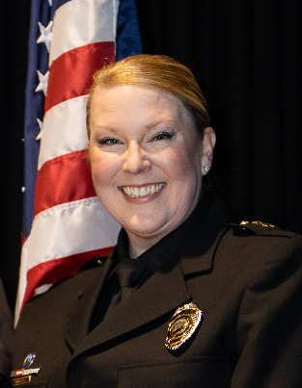

Presentation Title:

Contaminated Twice: Toxic Exposure, Trauma Recovery, and the Resilience Room™ Model for Arson Investigation Teams Presentation Abstract: Arson investigators face a compounded occupational hazard rarely addressed in first responder wellness models: repeated exposure to accelerants, combustion byproducts, and carcinogenic particulates, layered on top of the cumulative psychological toll of scene investigation, fatality cases, and prosecutorial testimony. Their canine partners — trained to physically locate and indicate on accelerant residue — share this same toxic exposure with none of the same recovery infrastructure. This presentation introduces the Resilience Room™ model developed by Heroes Resilience Initiative™ (HRI), a physiological recovery framework grounded in ICISF/CISM/CISD crisis intervention standards and applied specifically to the decontamination and recovery needs of arson investigation teams — both human and canine. Attendees will learn how post-scene physiological decontamination protocols, paired with structured psychological recovery tools, reduce cumulative toxic and traumatic load; how the Canine Resilience Initiative™ extends this model to accelerant-detection K9s, addressing a critical and largely unmet need in working dog recovery; and how agencies can implement scalable, field-deployable recovery infrastructure without requiring a mental health professional on-site for every session. Drawing on real-world agency deployment data, including voluntary utilization outcomes following high-stress callouts, this session offers a practical, evidence-informed model that arson investigation units can adapt to protect the long-term health and operational readiness of both their personnel and their K9 teams.

BIO: Christa Trinchera is the Founder and Executive Director of Heroes Resilience Initiative™ (HRI), a first responder wellness organization building physiological and psychological recovery infrastructure for law enforcement, fire service, and allied public safety professions. She is the architect of the Resilience Room™ model — a recovery framework grounded in ICISF/CISM/CISD crisis intervention standards — designed to give agencies a scalable, field-deployable answer to cumulative toxic exposure and traumatic stress without requiring a mental health professional physically on-site for every session. The Resilience Room™ model is currently operating under an active Memorandum of Understanding with the Bingham County Sheriff's Office in Idaho, where its first deployment was driven by a high-stress SWAT callout and has since demonstrated strong voluntary utilization among the deputies it was built to serve. HRI has additional agency ribbon-cuttings underway, and a Mobile Resilience Room is currently deployed in support of FIFA World Cup 2026, with further wellness deployment planning in progress for the LA Olympic Games 2028 — reflecting HRI's growing role in supporting public safety personnel operating under sustained, high-demand operational conditions. Christa also leads HRI's Canine Resilience Initiative™ and Warhorse Resilience Initiative™, extending decontamination and recovery protocols to working K9s and mounted patrol animals. This work — including research into modalities such as PEMF and Halo therapy — addresses a largely unmet need in working-animal wellness, recognizing that K9 partners and patrol horses absorb many of the same occupational hazards as their handlers with far less recovery infrastructure built around them. In addition to her work at HRI, Christa brings over a decade of experience as a law enforcement chaplain and directs the National Chaplain Development Program, through which she has supported federal grant initiatives such as the STREETS Initiative. She brought the first fire chaplain program to Eastern Idaho, and she has served on the Governor's Task Force to combat veteran suicide since 2022 — extending her focus on trauma, resilience, and recovery beyond active-duty first responders to the veteran community as well. This dual foundation — hands-on chaplaincy experience paired with a crisis-intervention and program-building background — shapes her approach to first responder wellness: practical, evidence-informed, and built to fit the operational realities of the field rather than requiring extensive clinical overhead. Christa is the daughter of a retired California Highway Patrol Sergeant, and her work reflects a lifelong proximity to the demands and toll of public safety service.

Fundamentals of Fire Investigation (40 Hours – Tested)
Dates: Monday, Nov. 2 – Friday, Nov. 6, 2026 Time: 7:30 AM – 5:00 PM
(Mon–Thurs), Noon end time Friday Provider:

IAAI International · Host: Idaho Chapter 56 Location: Kootenai County Fire & Rescue - Training & Maintenance Campus. This IAAI-provided tested 40-hour course qualifies for the IAAI-FIT Track A requirement. It establishes the foundation for a successful fire investigator, covering the scientific method, fire dynamics, documentation, ventilation effects, ignition sources, evidence collection, and more.

We extend a sincere thank you to the Kootenai County Fire & Rescue for serving as our host agency for the 2025 IAAI Idaho Chapter Annual Conference. Their support and partnership make this training possible.


Official Conference Hotel- Idaho IAAI Conference 2026
Available Rooms - Hampton Inn & Suites Coeur d' Alene
Right click and open the hyperlink to book you rooms.

