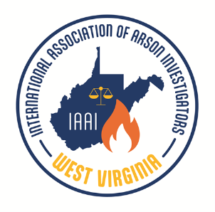

The West Virginia Chapter
of the
International Association of Arson Investigators
Presents
2023 Fire Investigation Conference

Monday and Tuesday, October 16thand 17th 2023
Morgantown, West Virginia

Topics include:
The DC Mansion Murders (4 Hours)
Detective Michael Pavero (Metropolitan Police)
This course will review the case facts, investigative steps and evidence used to convict Daron Wint, who was found guilty of the Murder of 4 people and Arson on what is known as the "DC Mansion Murders." Due to the nature of this case, taking pictures or images during the presentation will be prohibited.

Introduction to National Insurance Crime Bureau
Analysis of historical cell site location records and Google location records and vehicle tracking (4 hours)
Special Agent Chris Doyle (NICB)
ASFM Joe Vacchio (WV Office of the State Fire Marshal)
This course introduces the National Insurance Crime Bureau as well as the use of location data in tracking related to fire investigations.

Fire Dynamics (4 Hours)
Dr. Gregory E. Gorbett (EKU)
This workshop introduces investigators to fire and explosion dynamics as it applies to origin and cause determinations.

Strategies to Disqualify the Opponent’s Expert Witness and Bolster Your Expert (4 Hours)
Dr. Gregory E. Gorbett (EKU)
This workshop introduces investigators to the standards of care for the fire and explosion investigation profession. Participants will be able to explain the qualifications that must be satisfied for an individual to testify as an expert witness at trial. Participants will compare the practices found in bolstering strong expert witness testimony and disqualifying opponent’s expert witness. Participants will also review the strategies used by opposing experts for establishing strong arguments against origin and cause findings.

Host Hotel and Conference Center

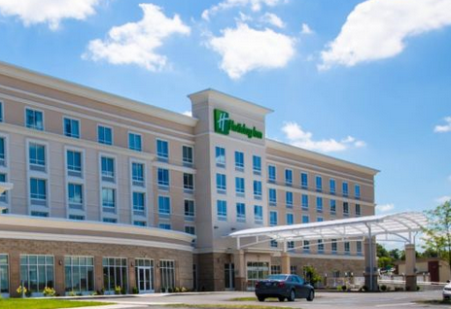



1188 Pineview Drive
Morgantown, WV 26505
304-241-6649
www.holidayinn.com/morgantownunv

ROOM AVAILABILITY

A block of rooms is reserved for arrival on
Sunday, October 15th with check out on Tuesday, October 17th.
The cost per room is $109.00 - $119.00 per night depending on occupancy.

The Group Name/Link is :

Fire Investigators Conference

The room block is limited and you are encouraged to make your room reservation as soon as possible.

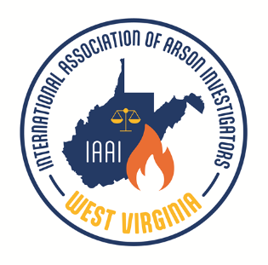
SEMINAR REGISTRATION

IAAI Members $175.00
Non-Members $200.00
Students* $100.00
*Student rate applies to those currently enrolled in a Fire Science, Forensics or Criminal Justice program.

Registrations received after the class size limit is reached will be returned.

PLEASE REGISTER EARLY

This is a tested course for points toward IAAI-CFI Continuing Education and Law Enforcement in-service training credit. Training Certificates are issued by the West Virginia Chapter of the IAAI.
The WVIAAI reserves the right to refuse admission to any party.

Name: _______________________________________________________

Organization: _______________________________________________________

Address: _______________________________________________________

_______________________________________________________

Telephone: _______________________________________________________

E-mail: _______________________________________________________

Seminar Schedule: Seminar Contacts:

Classes: 8:00 am – 5:00 pm both days Jon Jorgensen 304-541-2910
Lunch on your own from 12:00 am – 1:00 pm Korri Powers 304-542-6126

Return registration form with payment to:
West Virginia Chapter IAAI
P. O. Box 1218
Scott Depot, WV 25560

You may email registrations to korrih@yahoo.com or jonathan.jorgensen@thehartford.com

