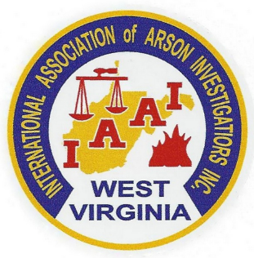

The West Virginia Chapter
of the
International Association of Arson Investigators
Presents
2022 Fire Investigation Conference

Monday and Tuesday, October 10th and 11th 2022
Morgantown, West Virginia

Topics include:
Case Study – Everett Community College Fire (2 hours)
The Internet of Things and its Use in Fire Investigations (2 hours)
Supervisory Special Agent Dawn Dodsworth (ATF)
As seen on A&E Network’s Cold Case Files, this presentation covers a 34 year old, cold case firefighter line of duty death recently closed with arrest and conviction. The presentation also includes doctoral research on how the use of data from the Internet of Things connected building systems can assist the fire investigator in narrowing down the area of origin, thus making conclusions more empirical.

Fatal Fire Scenes (4 hours)
ASFM Scott Rodes & ASFM Shawn Alderman (WV Office of the State Fire Marshal)
This course will cover the basic investigative responsibilities present at fatal fire scenes as well as methods and techniques for examination and documentation of the scene as well as evidence recovery.

Lithium Batteries – What you need to Know (8 hours)
Brad O’Neal, PE (Forensic Investigation Research Experts - FIRE)
The course is an overview of Lithium battery failure modes and how the evidence presents itself. The forensic investigator will learn ways to investigate, document, and transport Lithium batteries safely.

Host Hotel and Conference Center

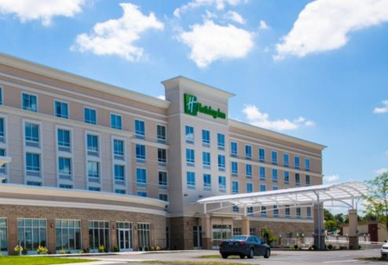

1188 Pineview Drive
Morgantown, WV 26505
304-241-6649
www.holidayinn.com/morgantownunv

ROOM AVAILABILITY

A block of rooms is reserved for arrival on
Sunday, October 9th with check out on Tuesday, October 11th .
The cost per room is $109.00 - $119.00 per night depending on occupancy.

The Group Name/Link is FIC

Fire Investigators Conference

The room block is limited and you are encouraged to make your room reservation as soon as possible.

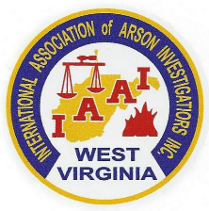
SEMINAR REGISTRATION

IAAI Members $175.00
Non-Members $200.00
Students* $100.00
*Student rate applies to those currently enrolled in a Fire Science, Forensics or Criminal Justice program.

Registrations received after the class size limit is reached will be returned.

PLEASE REGISTER EARLY

This is a tested course for points toward IAAI-CFI Continuing Education and Law Enforcement in-service training credit. Training Certificates are issued by the West Virginia Chapter of the IAAI.
The WVIAAI reserves the right to refuse admission to any party.

Name: _______________________________________________________

Organization: _______________________________________________________

Address: _______________________________________________________

_______________________________________________________

Telephone: _______________________________________________________

E-mail: _______________________________________________________

Seminar Schedule: Seminar Contacts:

Classes: 8:00 am – 5:00 pm both days Jon Jorgensen 304-541-2910
Lunch on your own from 12:00 am – 1:00 pm Korri Powers 304-542-6126

Return registration form with payment to:
West Virginia Chapter IAAI
P. O. Box 1218
Scott Depot, WV 25560

You may email registrations to korrih@yahoo.com or jonathan.jorgensen@thehartford.com

