Two Sides North America – New October 2026 Social Content to Share

Below are a few key posts from Two Sides North America and Love Paper for October. We have highlighted the dates that we will share the posts for reference. We have also shifted many of our posts to the 1080 x 1350 resolution, or the 4:5 ratio, now used for IG and FB. Please feel free to cut and paste the content to share this information on your own social channels. We have included the relevant links and hashtags, and you can edit the posts to fit your style and tone. Please remember to tag us in your post!
X (Twitter): @TwoSidesNA
LinkedIn: @TwoSidesNA or @LovepaperCampaign
Instagram: @TwoSidesNA or @LovePaperCampaign
Facebook: @TwoSidesNorthAmerica or @LovePaperCampaign

Note: Right-click the images and choose Save as Picture or log into FileCamp for video clips
Days to note this month:

National Newspaper Week = October 4th-10
Canadian Thanksgiving = October 12th
National Forest Products Week = October 18th -24th
World Sustainability Day = October 28th
Halloween = October 31st

October 1st  LP | LinkedIn  Instagram  Facebook | 📦 Shop the box! Next time you're comparing products, take a closer look at the packaging.  Could you choose the cardboard box instead of the plastic container? From cereal to laundry products to electronics, paper-based packaging can be a smart choice—and it can often be recycled.  Consider yourself a Papertarian!  Learn more: https://lovepaperna.org/.../so-you-want-to-be-a-papertarian/ | 
October 2nd  LP | LinkedIn  Instagram  Facebook | Love notebooks? 📓 You might just be a Papertarian. If you love the feel of a fresh page, filling a notebook with ideas, making lists, sketching, journaling—or simply collecting notebooks you swear you’ll use someday—welcome to the club.  Paper is practical, creative, and made to be used, reused and recycled. Go ahead. Embrace your inner #Papertarian.  #LovePaper #PaperLovers #PaperFacts #ChoosePaper  https://lovepaperna.org/.../so-you-want-to-be-a-papertarian/ | 
October 5th  TSNA | LinkedIn  Instagram  Facebook  X(Twitter) | If your organization sends transactional mail, direct mail, or printed communications at any volume, you have a stake in how the public perceives the environmental footprint of paper—and right now, that perception is out of step with reality. Read more here:  https://twosidesna.org/what-the-data-says-about-paper-mail-and-the-environment-and-why-it-matters-to-your-operation/  #print #mail #paperfacts | 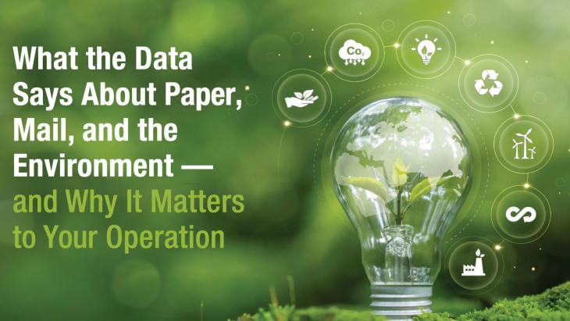
October 6th  TSNA | Instagram  Facebook  LinkedIn  X (Twitter) | It’s National Newspaper Week! Did you know 54% of people would be concerned if printed newspapers disappeared?  This week, we’re celebrating the journalists, publishers, printers and readers who keep print journalism thriving. Some stories are worth putting on paper.  https://twosidesna.org/trend-tracker-2025/  #NationalNewspaperWeek #TwoSides #Newspapers #PrintMatters #PaperIndustry | 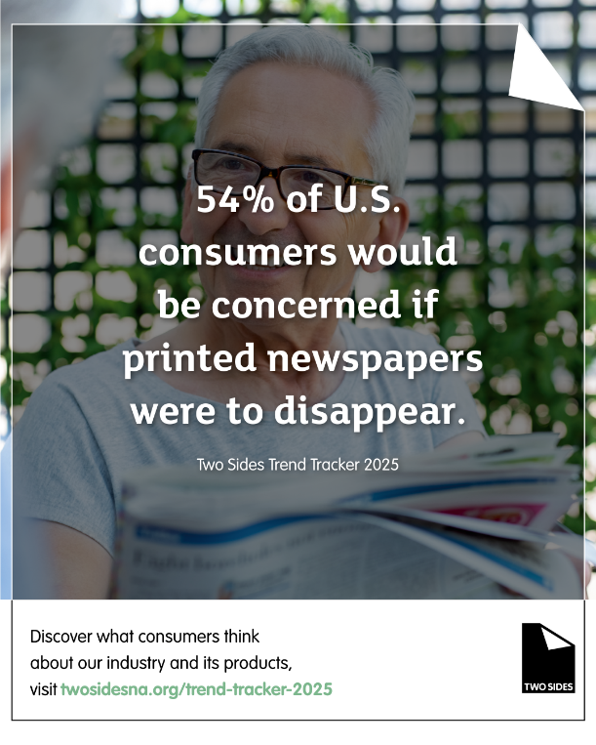
October 7th  LP | LinkedIn  Instagram  Facebook | Consumers and businesses want a better option. Paper packaging is answering the call. It’s not a compromise. It’s an upgrade.  In a direct comparison with plastic, glass, and metal, paper came out on top in 10 out of 15 attribute categories—outperforming every other material.  https://lovepaperna.org/packaging/  #LovePaper #packaging | 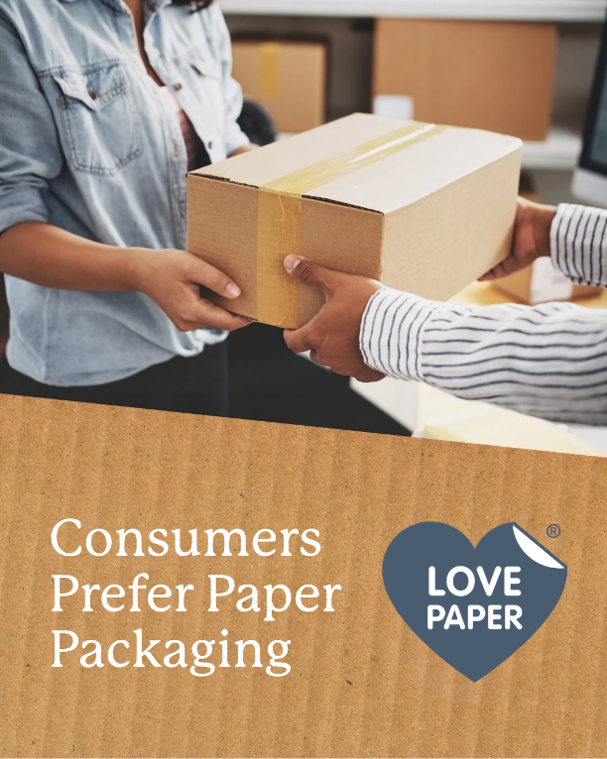
October 7th  TSNA | LinkedIn  Instagram  Facebook  X(Twitter) | The paper industry doesn't simply use forests—it has a vested interest in maintaining a sustainable supply of fiber.  🌲 Healthy forests. Renewable fiber. A circular material.  https://twosidesna.org/paper-deforestation-and-the-truth-about-sustainable-forests/  #TwoSidesNA #SustainableForestry #PaperFacts #Forests #CircularEconomy | 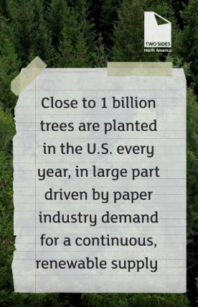  Video: https://files-twosidesna.filecamp.com/s/i/Yker2va7SHpcjEtX
October 8th  TSNA | LinkedIn  Instagram  Facebook  X(Twitter) | Ready to Bust some Myths? When it comes to the sustainability of print and paper, it is important to separate myths from facts.  Learn more https://twosidesna.org/mythsandfacts  #paperfacts #paper #packaging #printindustry #forestry #sustainable #recycle | 
October 9th  TSNA | LinkedIn  X (Twitter)  Facebook  Instagram | Did you know that over 64% of U.S. consumers worry about the privacy of their electronically stored personal data? Because of this, many still prefer and trust having their important documents in print.  Find out more about consumer perceptions about paper in the Trend Tracker 2025 report: https://twosidesna.org/trend-tracker-2025/  #PrintIsPreferred #DataPrivacy | 
October 13th  TSNA | LinkedIn  Facebook  Instagram  X (Twitter) | More than 1,500 companies worldwide have now pulled back or amended unsupported environmental claims that unfairly position paper and paper-based packaging as harmful to the environment.  In North America, @TwoSidesNA has challenged 422 companies, with 228 companies—more than half—changing or removing unsupported anti-paper messaging.  As the paper and packaging industry continues to advance responsible forestry, renewable fiber, recycling and circularity, accurate communication about environmental impacts matters.  https://twosidesna.org/two-sides-continues-to-challenge-greenwashing-claims-reaches-a-global-milestone/  #TwoSides #PaperIndustry #Greenwashing #Sustainability | 
October 14th  TSNA | LinkedIn  Facebook  Instagram  X (Twitter) | Paper is a natural fit for the circular economy. Renewable wood fiber can be converted into paper and packaging products, recovered through recycling, and used to produce new products—keeping valuable fiber in circulation and reducing waste.  https://twosidesna.org/wp-content/uploads/sites/16/2026/03/US_Fact_Sheet_Recycling_WEB_012426.pdf  #TwoSides #CircularEconomy #PaperRecycling #Sustainability | 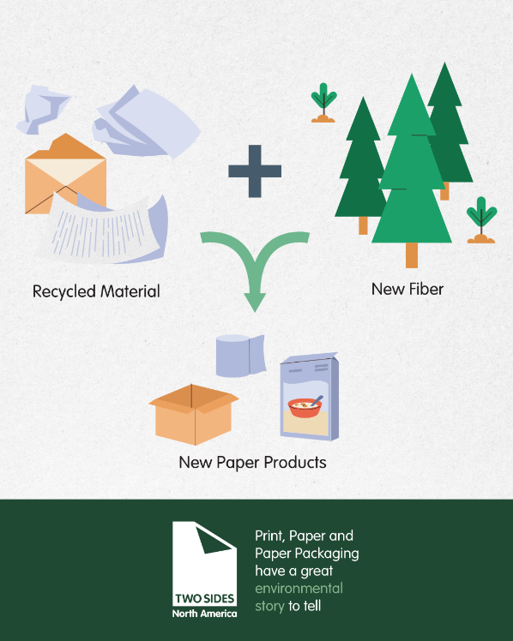
October 15th  LP | LinkedIn  Facebook  Instagram | Whether you’re reading a magazine, making a handwritten grocery list or buying products in paper packaging, you’re benefiting our forests. Learn more and become a #Papertarian today!  https://lovepaperna.org/2026/04/15/papertarian-make-the-smart-lifestyle-choice/ | 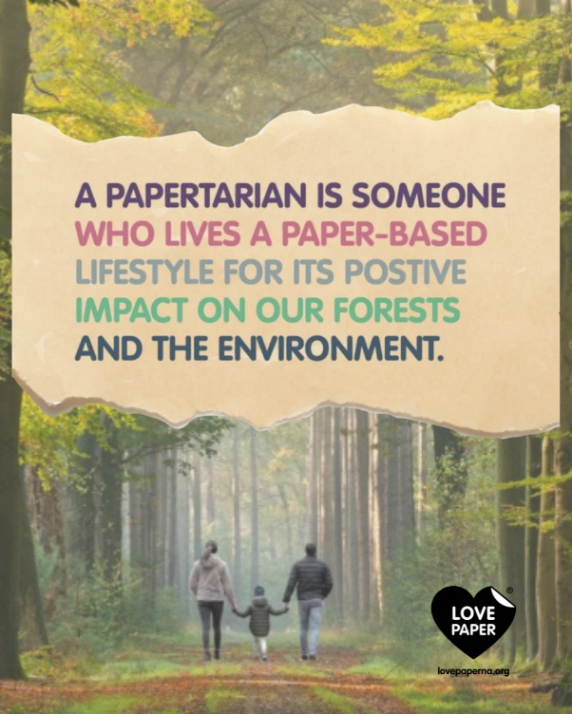
October 19th  TSNA | LinkedIn  Facebook  X (Twitter)  Instagram | It's National Forest Products Week! 🎉 Let's appreciate the paper products we rely on every day, crafted from renewable and sustainable resources. 🌲📄  #nationalforestproductweek | 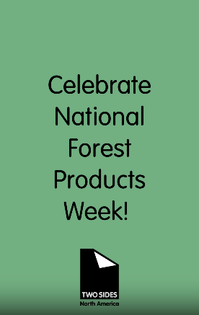  Video: https://files-twosidesna.filecamp.com/s/i/poI3vaKny80erkA3
October 19th  LP | LinkedIn  Facebook  Instagram | It’s National Forest Products Week! 🌲📄  Today, we’re celebrating PAPER—one of the most versatile forest products and a critical part of everyday life.  📰 Newspapers & magazines  📚 Books  📓 Notebooks & stationery  🖨️ Office & printing paper  ✨ Specialty papers  From the stories we read to the ideas we put on the page, paper helps us connect, create and communicate.  And when we’re finished, paper can be recycled, and its valuable fibers given another life.  #LovePaper #NationalForestProductsWeek #Paper #PaperFacts #ChoosePaper #Sustainability | 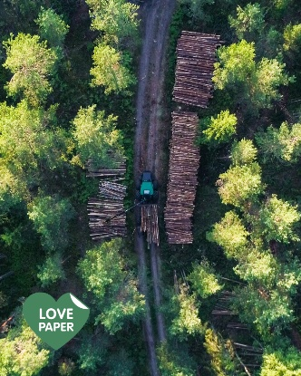
October 20th  TSNA | LinkedIn  Facebook  Instagram  X (Twitter) | Sustainability in the paper industry extends across the entire value chain—from forest management and fiber sourcing to manufacturing, product use, collection and recycling. Each stage contributes to the industry's broader environmental performance.  Learn more: https://twosidesna.org/mythsandfacts  #TwoSides #PaperIndustry #Sustainability #CircularEconomy | 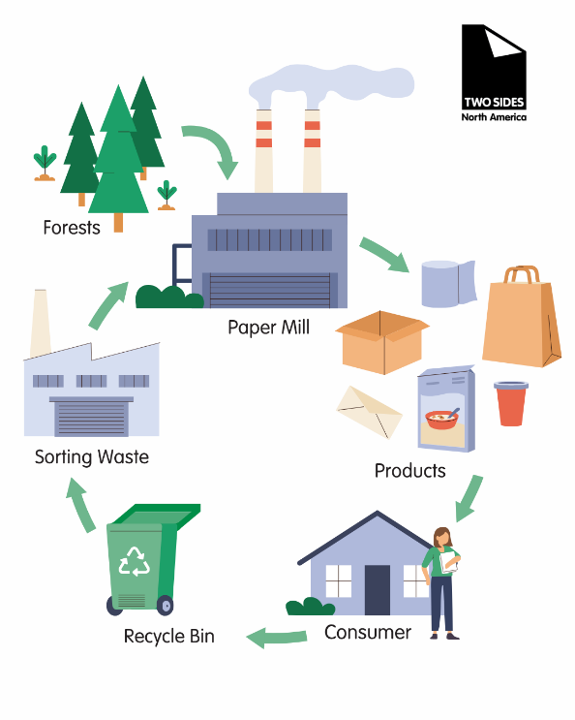
October 21st  LP | LinkedIn  Facebook  Instagram | It’s National Forest Products Week! 🌲  Today, we’re celebrating TISSUE & PAPER TOWELS—everyday paper products that bring convenience, cleanliness and comfort to our families, homes and workplaces.  🧻 Facial tissues  👐 Paper towels  🚻 Bathroom tissue  🍽️ Napkins  Made from wood fiber, these essential products show how forest resources become useful products we rely on every day.  Small sheets. Big impact. Celebrate tissue & paper towels!  #LovePaper #NationalForestProductsWeek #PaperProducts #Tissue #PaperTowels #PaperFacts #Sustainability | 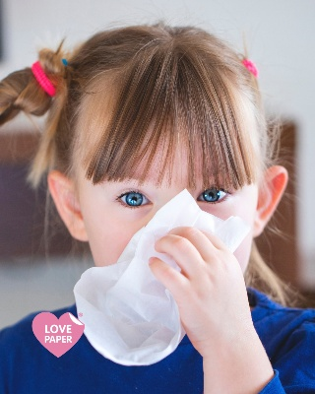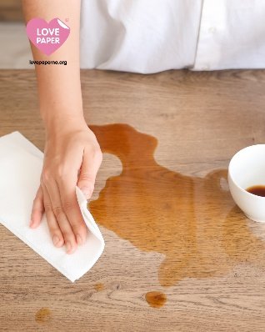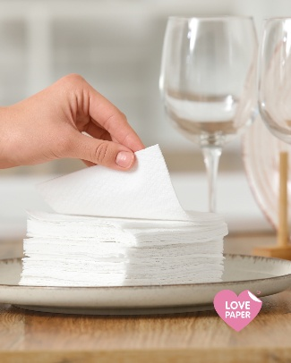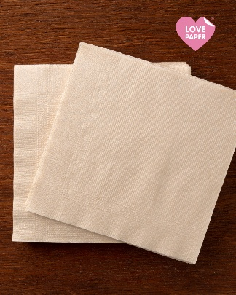
October 22nd  TSNA | LinkedIn  Facebook  Instagram  X (Twitter) | Environmental claims about products and services are not just marketing—they’re subject to strict rules. The U.S. Federal Trade Commission and the Competition Act in Canada require that claims be truthful, specific, and supported by competent, reliable scientific evidence.  Learn more:  https://twosidesna.org/wp-content/uploads/sites/16/2026/06/US_Fact_Sheet_Greenwashing_WEB_062426-2.pdf  #environmentalclaims #greenwashing | 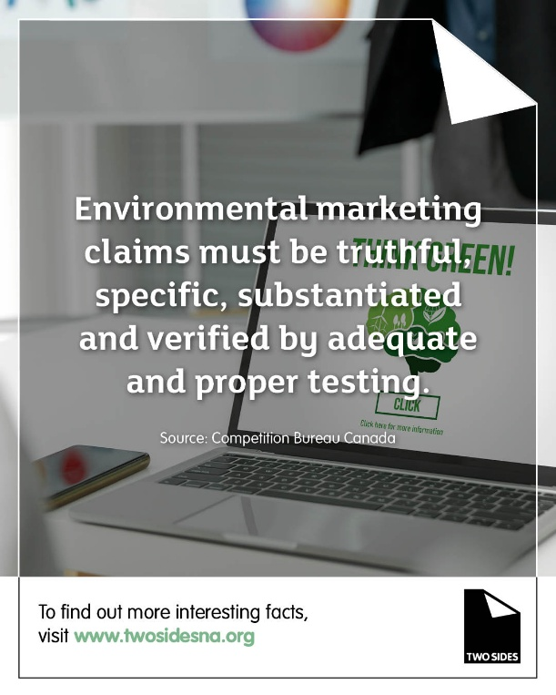
October 23rd  LP | LinkedIn  Facebook  Instagram | Happy National Forest Products Week! 🌲 Today marks the final day of our celebration.  All week, we’ve shared some of our favorite forest-derived essentials, including packaging, paper, tissue, envelopes, mail, and labels. Did you know that choosing paper products actually provides a direct financial incentive to plant and grow more trees?  So many everyday items come from responsibly managed forests. Which of your favorites did we miss?  #LovePaper #NationalForestProductsWeek #ForestProducts #PaperFacts #Sustainability #ChoosePaper | 
October 26th  TSNA | LinkedIn  Facebook  Instagram  X (Twitter) | Paper recycling extends the useful life of wood fiber and plays a critical role in the industry's circular model. Strong collection, sorting and recycling systems help recover valuable fiber and return it to productive use.  Get the facts: https://twosidesna.org/wp-content/uploads/sites/16/2026/03/US_Fact_Sheet_Recycling_WEB_012426.pdf  #TwoSides #RecoveredFiber #PaperRecycling #CircularEconomy | 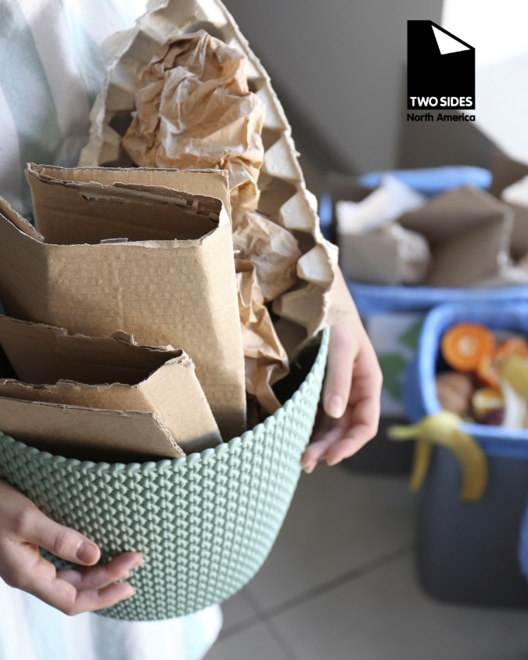
October 27th  TSNA | LinkedIn  Facebook  Instagram  X (Twitter) | Which is better for the environment? The answer isn't always as simple as “paper” or “digital.”  Both have environmental impacts. Both have benefits. And the right choice can depend on how a product is made, used, transported, recovered, and disposed of.  That's why fact-based decision-making matters.  @TwoSidesNA is working to make sure the sustainability story of print, paper, and paper-based packaging is based on facts—not myths.  https://twosidesna.org/  #TwoSidesNA #Sustainability #PaperFacts #AntiGreenwashing #PrintAndPaper |   
October 28th  TSNA | Instagram  Facebook  LinkedIn  X(Twitter) | Sustainability is about making thoughtful choices today that support a more resilient future.  Paper is a renewable, recyclable and responsibly sourced material that continues to play an important role in a circular economy. From communication and education to packaging and everyday products, paper remains a practical and sustainable choice when sourced and used responsibly.  #WorldSustainabilityDay #Sustainability #Paper #Packaging #CircularEconomy #ResponsibleForestry #TwoSidesNorthAmerica | 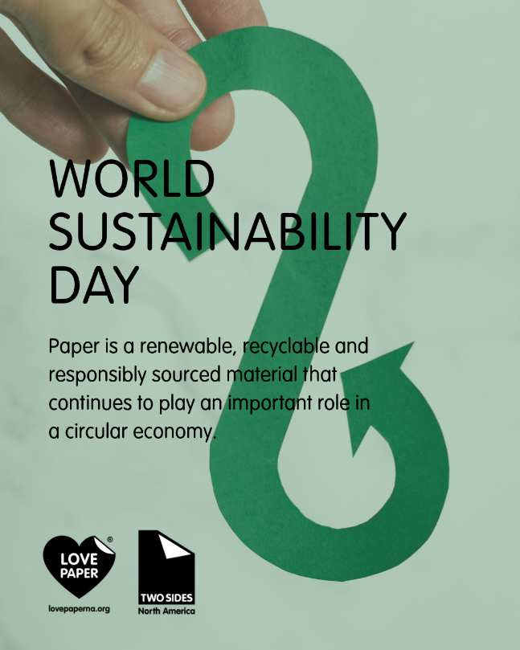
October 29th  TSNA | X (Twitter)  Instagram  Facebook  LinkedIn | Print, paper and paper packaging have a great environmental story to tell. You’re invited to bring your voice and join us!  @TwoSidesNA is a membership organization that promotes responsible environmental practices across the Paper, Print, Graphic Communications, and Paper-based Packaging industries.  Learn more and join today:  https://twosidesna.org/join-today/  #twosides #paperfacts #paper #print | 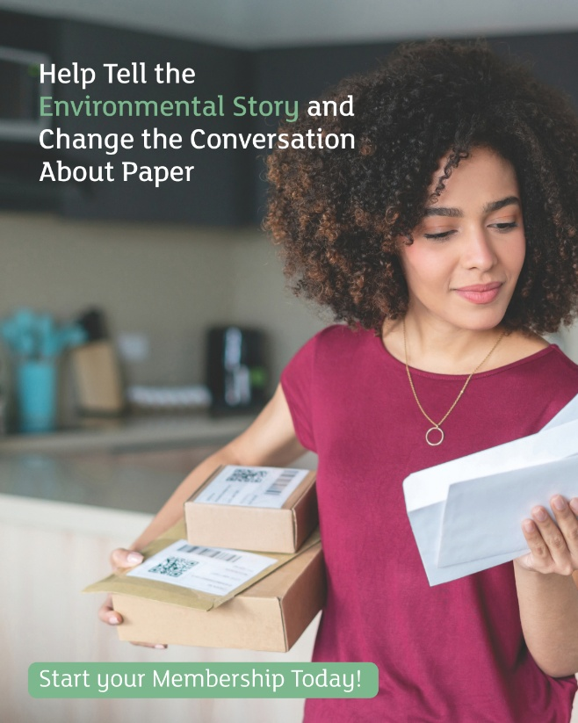
October 30th  TSNA | X (Twitter)  Instagram  Facebook  LinkedIn | Healthy forests and a strong paper industry are interconnected. Responsibly managed forests provide renewable fiber, while demand for forest products contributes to the economic value of maintaining productive working forests.  Get more Canadian #PaperFacts here:  https://twosidesna.org/resources/tsna/Canada-Myths-Facts-Sheet.pdf  #paper #forests #canadianforest | 

